DEPARTMENTAL PROFILE
1.NAME OF THE DEPARTMENT Department of Chemistry
2.YEAR OF ESTABLISHMENT 1984
3.DEPARTMENTAL E-MAIL ID deptchemistry946@gmail.com
4.PROGRAM OFFERED U.G.
5.STAFF DETAILS: SANCTION POST -01
FILLED POST -01
VACANT POST -NIL
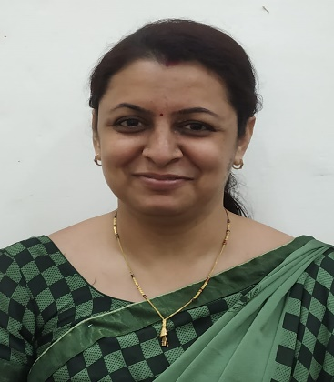
6.TEACHING STAFF
- NAME - Dr. Rainy Agrawal (M.Sc. CGSET, PhD)
- DESIGNATION - Guest Lecturer
- E-mail ID - rainyagrawal14@gmail.com
- SPECILIZATION -Chemistry
- NO. OF PUBLICATION - 07

7. LAB TECHNICIAN -NIL
8. LAB BEARER -NIL
9. STUDENT STRENGTH - 197
UG | PG | RESEARCH
197 | NIL | NIL

10. SWOC ANALYSIS
- Strengths
- Qualified and experienced faculty.
- Well-equipped laboratories with chemicals and instruments.
- Adequate lab space and safety facilities for hands-on experiments.
- Comprehensive syllabus as per university norms, updated with emerging areas of chemistry.
- Integration of theory with practicals to strengthen conceptual understanding.

- Weaknesses
- Absence of structured programs for student research or innovation.
- Laboratories are mainly designed for basic practical classes, not research.
- Students are more exam-oriented than research-oriented.
- Lack of trained staff (lab technician and lab attendant).
- Inadequate infrastructure.

- Opportunities
- Guidance for higher studies (M.Sc., NET, GATE) and other competitive examinations.
- Guidance for undergraduate-level jobs like forensic science and other job-oriented examinations.
- Summer research fellowships or special undergraduate research programs.
- Scope for entrepreneurship in chemical products, green chemistry, and sustainable solutions.

- Challenges
- Confusion between going for industry jobs, government jobs, or
higher studies (MSc, PhD).
- Intense competition for reputed institutes, fellowships, and jobs.
- Heavy workload with limited time for skill development or
innovation.

